**Regular Expression Practice Questions:-**

1. **Write a RegEx pattern in python program to check that a string contains a certain set of characters (in this case a-z, A-Z and 0-9)**

**We use the re module and re.findall function. to check that a string contains only a-z, A-Z and 0-9 we can use this following pattern:**

**pattern = (“[a-zA-Z0-9]”)**

**this pattern means that the string from the set of characters**

**(a-z) lowercase letters, (A-Z) uppercase letters and digits between(0-9).**

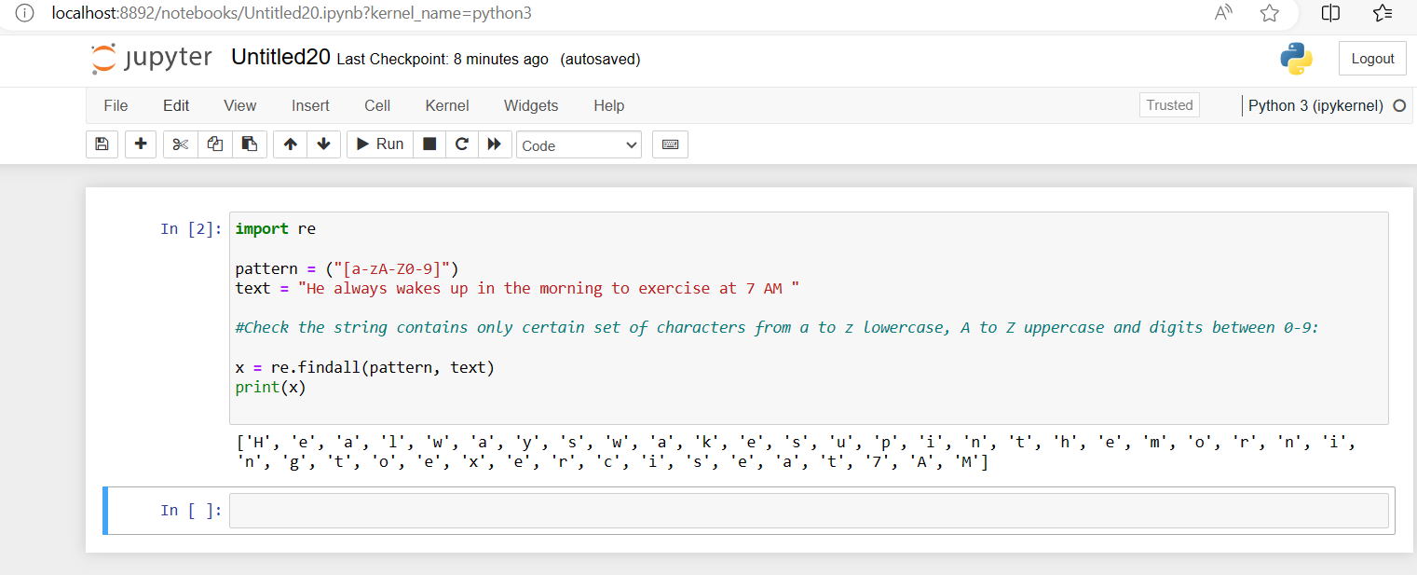

**Another method we use the re module re.match function.**

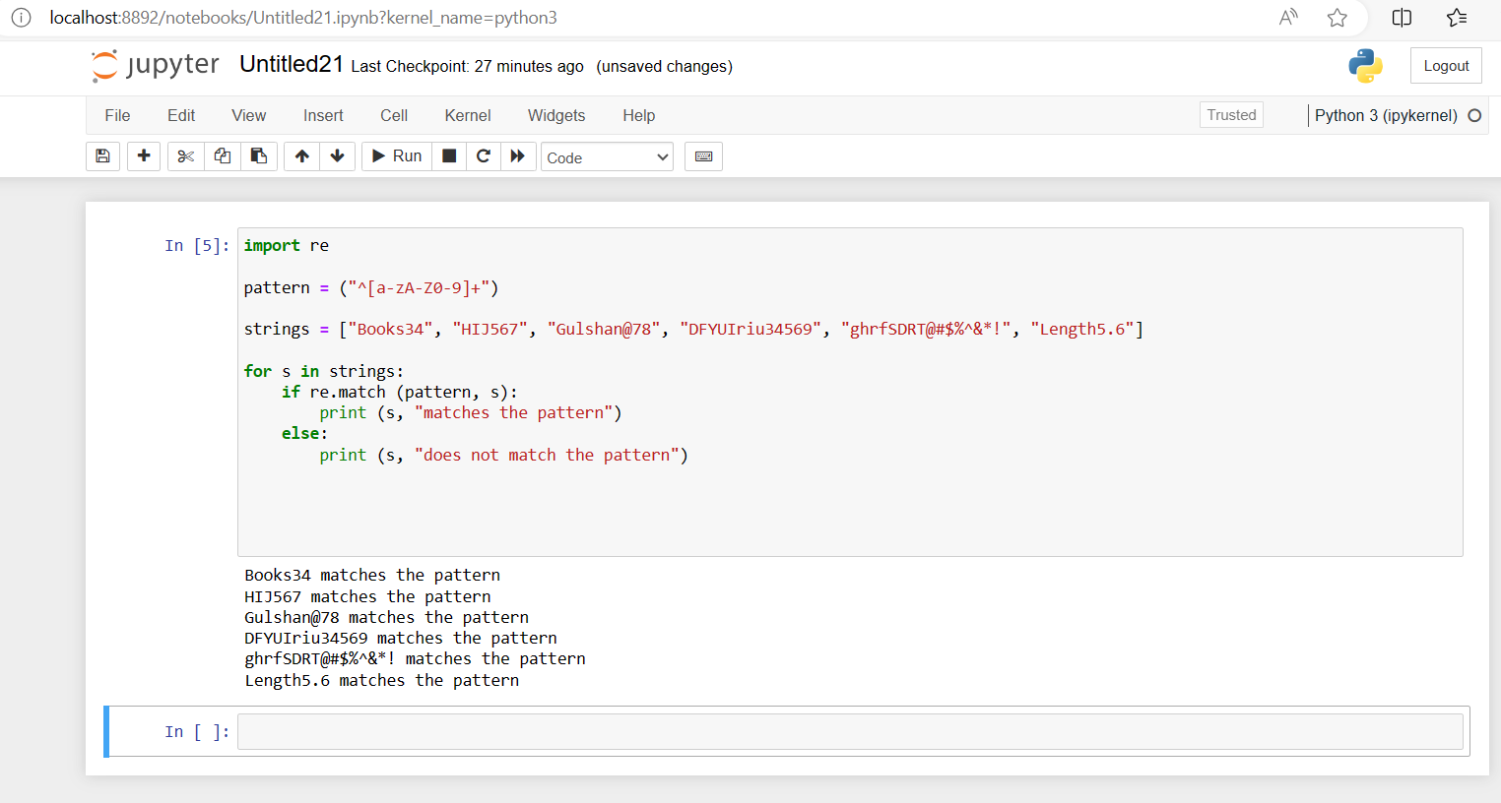

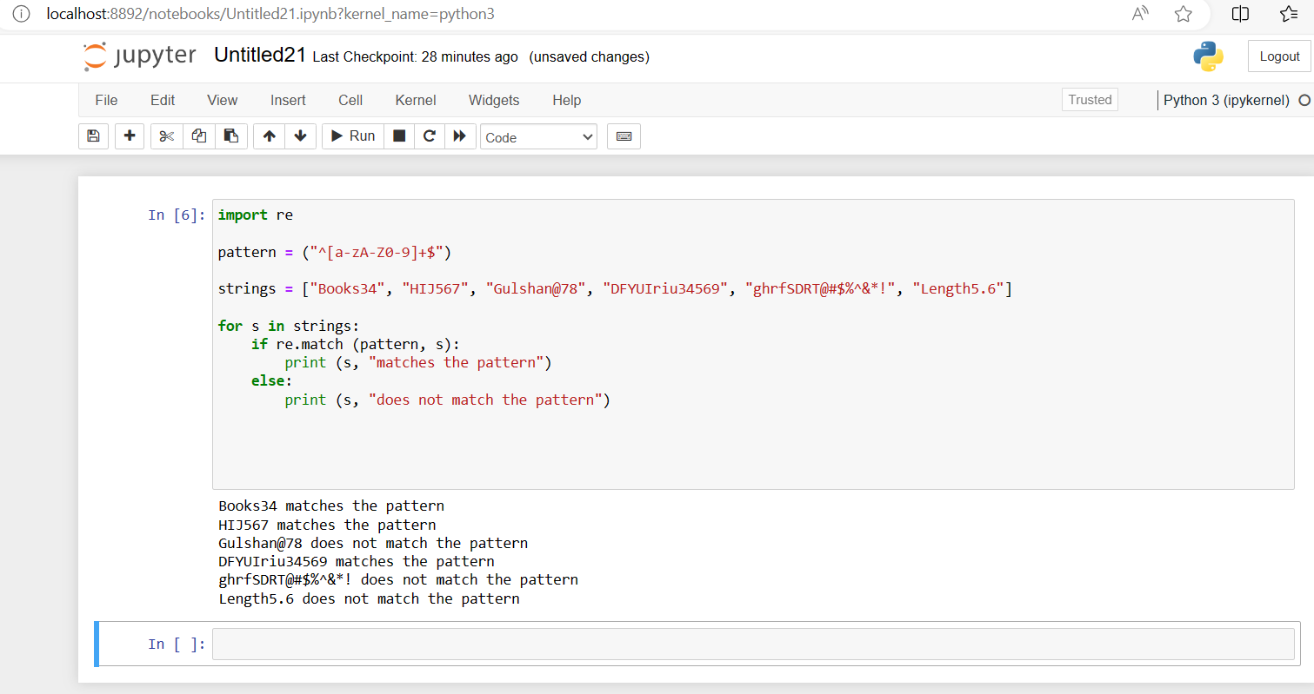

**This pattern means that the string must starts with (^), ends with ($) and one or more characters from the set of lowercase letters (a-z), uppercase letters (A-Z) and digit between (0-9). If the strings contains any other characters, such as space, punctuation or symbol, the match will fail.**

1. **Write a RegEx pattern that matches a string that has an a followed by zero or more b’s**

**We use to the re module and re.search function. re.search function is use to matches for the pattern on the string . (*) it is use to zero or more occurrences. Matches a string has an a followed by zero or more b’s. So we can write this pattern:-**

**pattern = “a(b*)”**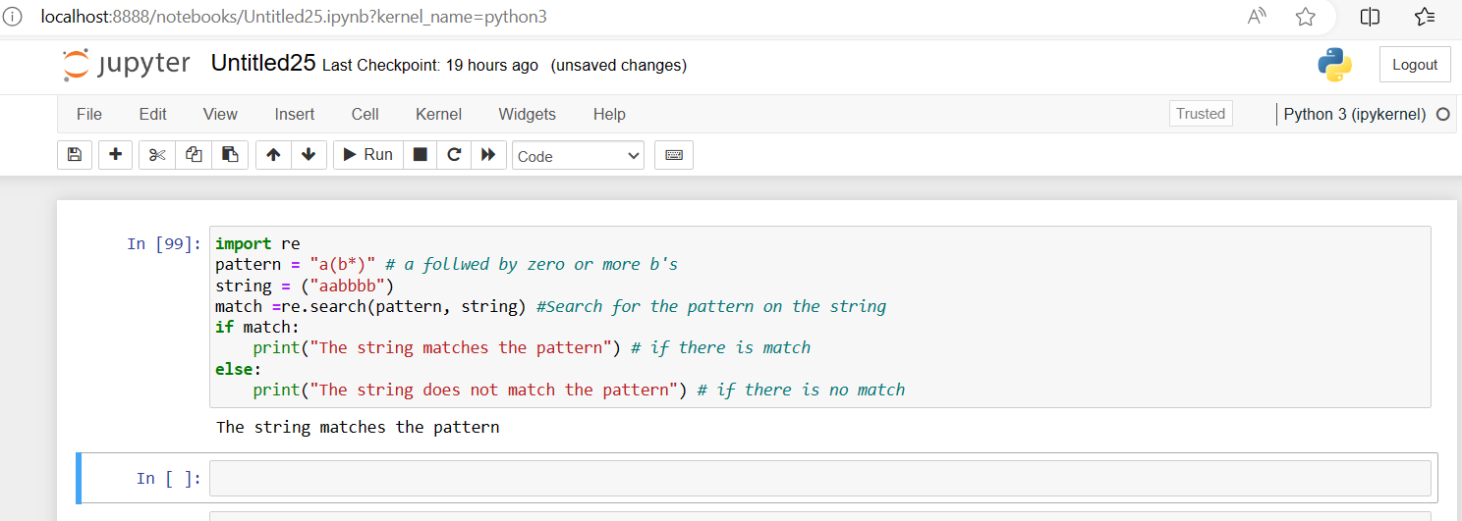

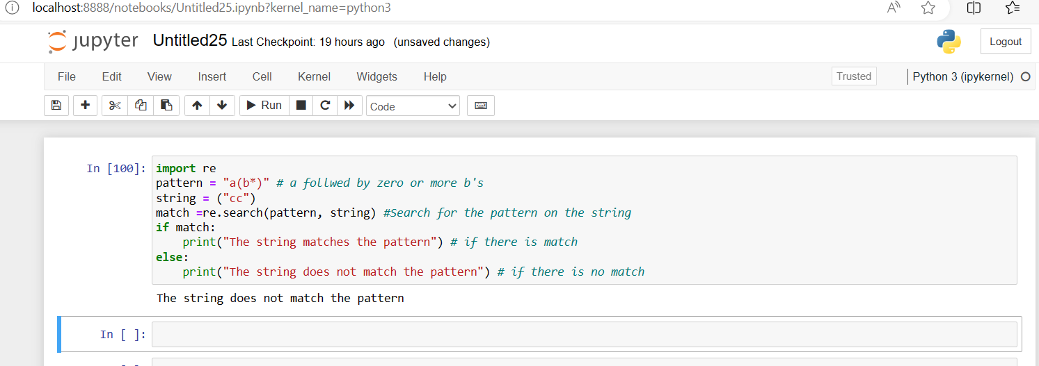

1. **Write RegEx pattern that matches a string that has a followed by one or more b’s**

**Here we use to the re module and re.search function. (+) it is use to one or more occurrences. Matches a string has an a followed by one or more b’s. So we can write this following pattern:-**

**pattern = “ab+”**

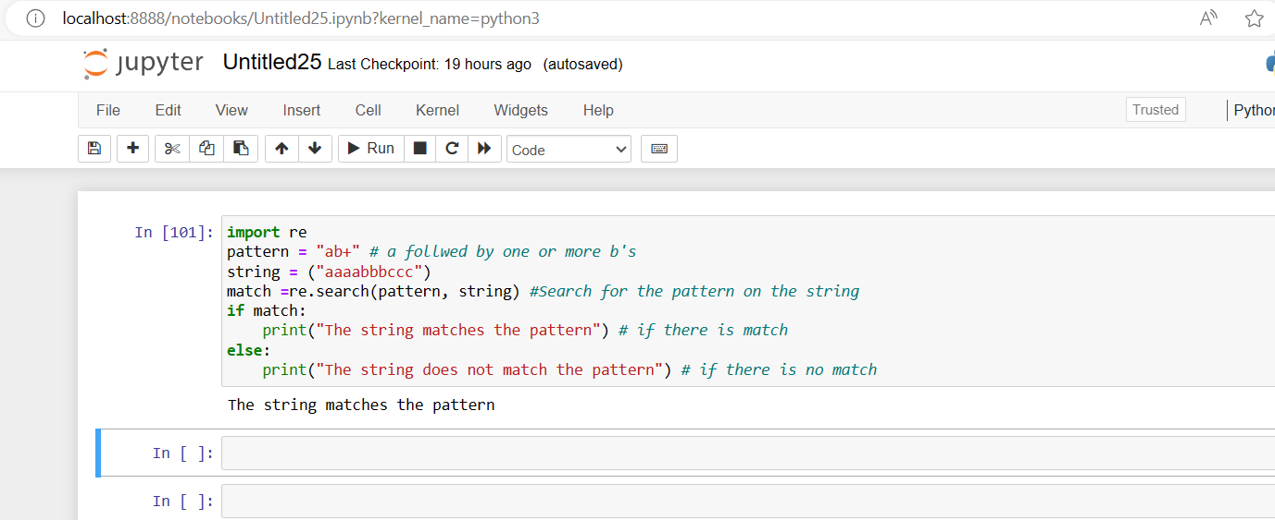

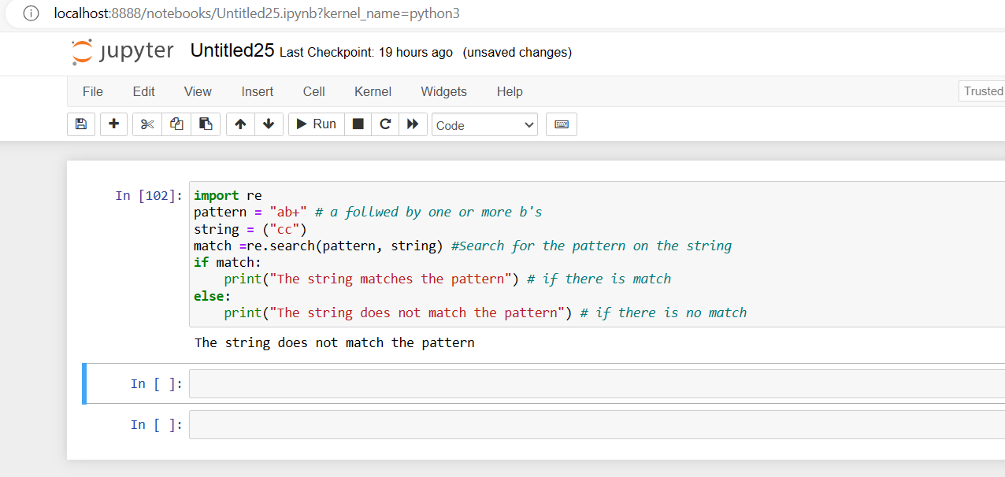

1. **Write a RegEx pattern that matches a string has an a followed by zero or one ‘b’**

**Here we use to the re module and re.search function. (?) it is use to zero or one occurrences. Matches a string has an a followed by zero or one ‘b’. So we can write this following pattern:-**

**pattern = “ab?”** 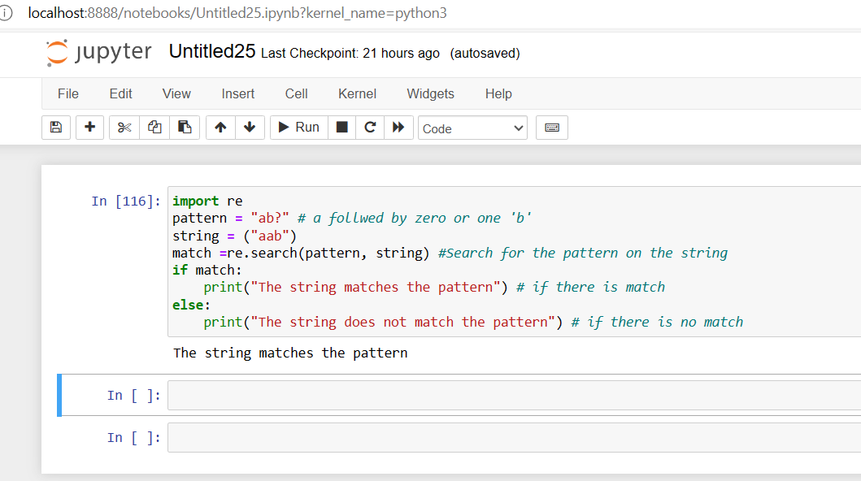

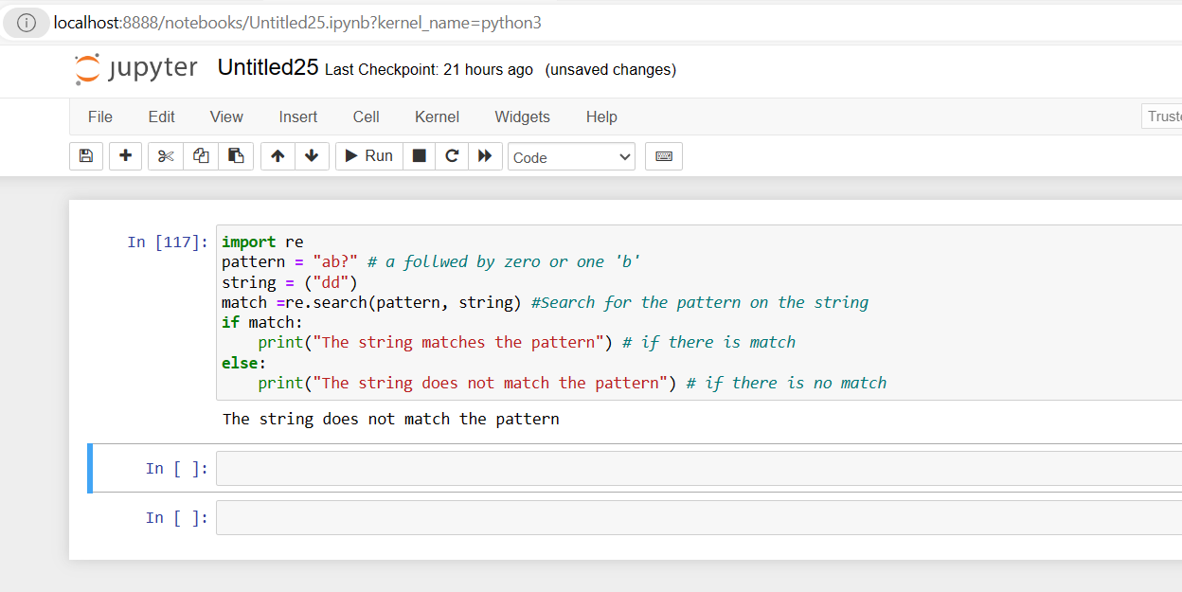

1. **Write a RegEx pattern in python program that matches a string that has an a followed by three ‘b’**

**Here we use to the re module and re.search function. {} it is use to exactly the specified number of occurrences. Matches a string that has an a followed by three ‘b’. so we can use this following pattern:-**

**pattern = “ab{3}”**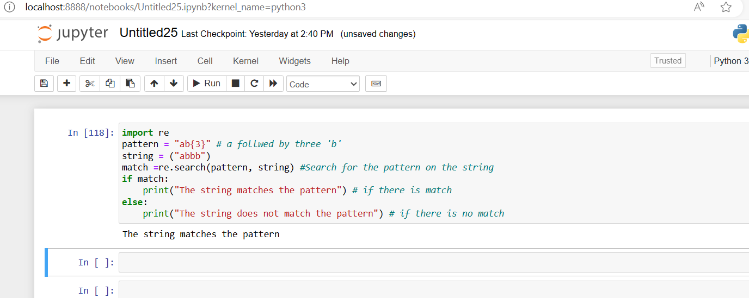

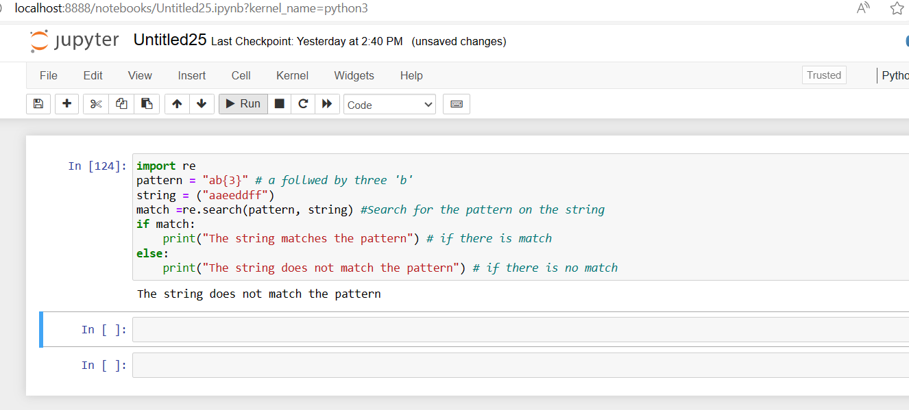

1. **Write a RegEx pattern in python program that matches a string that has an a followed by two to three ‘b’**

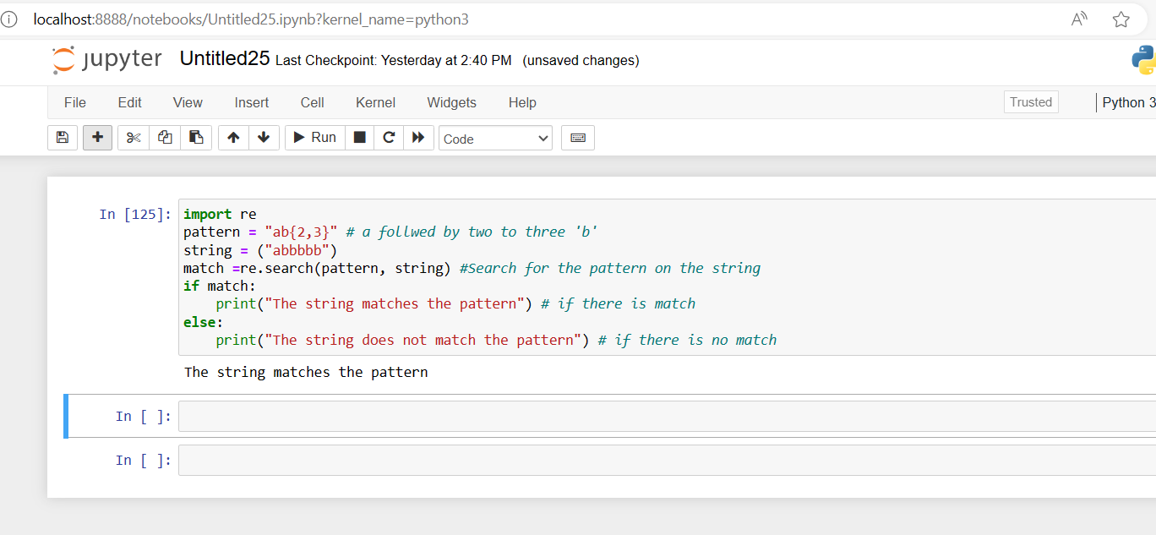

**Here we use to the re module and re.search function. {} it is use to exactly the specified number of occurrences. Matches a string that has an a followed by two to three ‘b’. So we can use this following pattern:-**

**pattern = “ab{2,3}”**

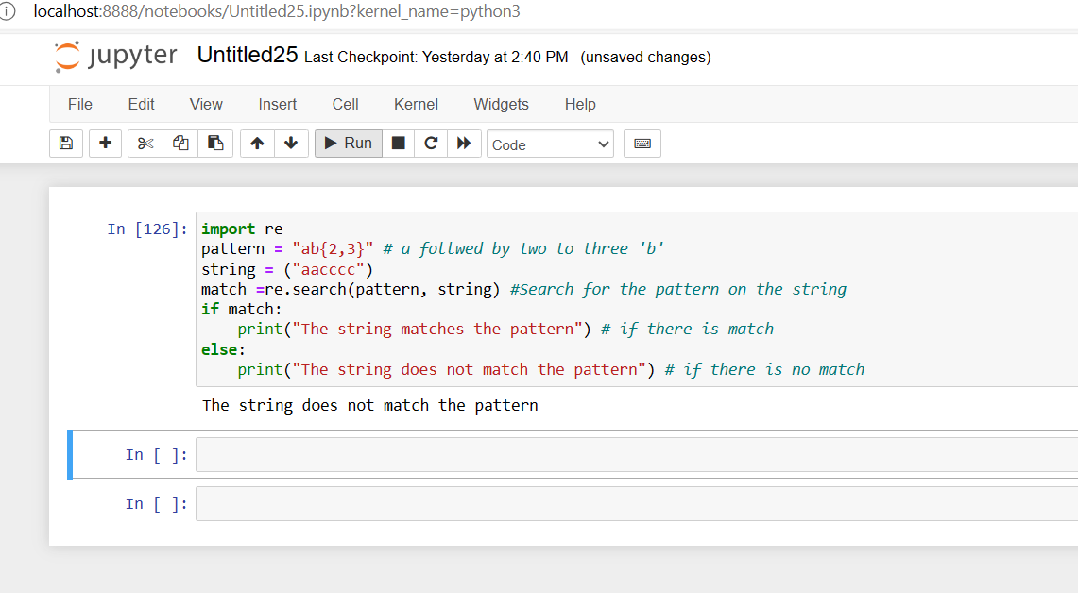

1. **Write a RegEx pattern in python program that matches a word at the beginning of a string.**

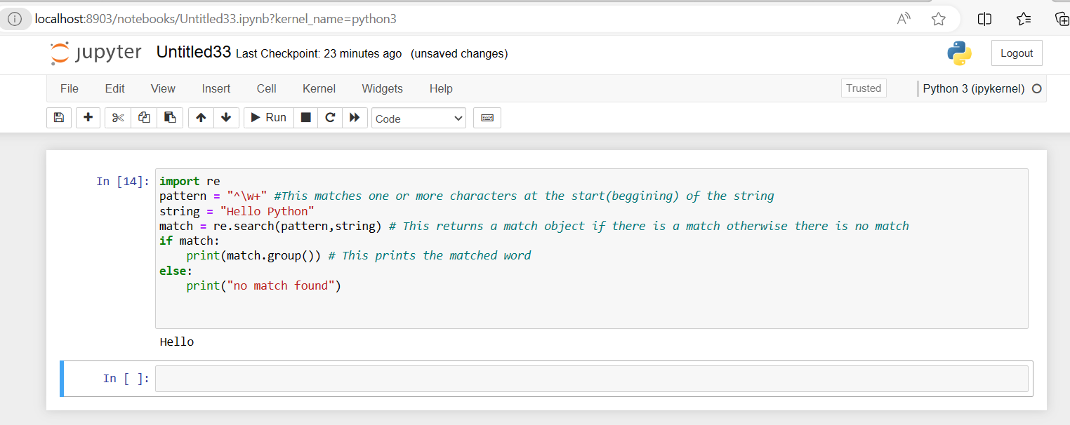

1. **Write a RegEx pattern in python program that matches a string at the end of a string.**

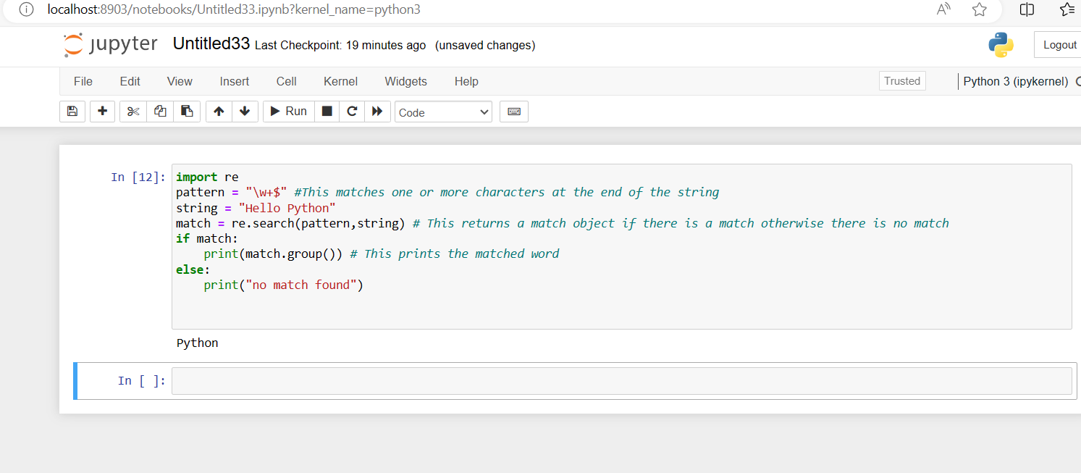**10. Write a RegEx pattern in python program to find all words that are 4 digit long in a string**

**Sample text- ’01 0132 231875 1458 301 2725’.**

**Expected output- [‘0132’, ‘1458’, ‘2725’]**

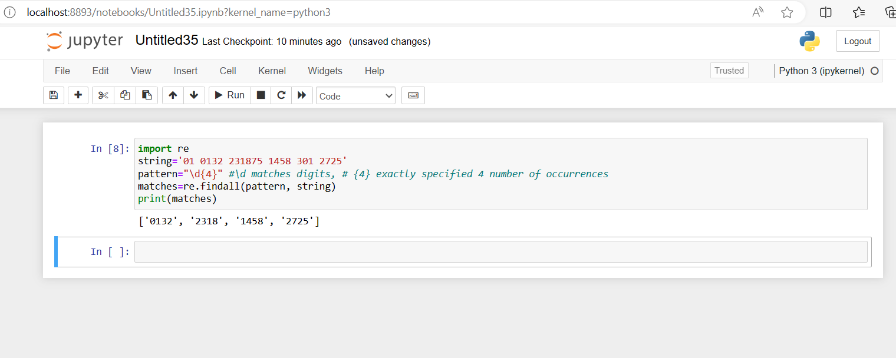

1. **Write a Python program that matches a string that has an ‘a’ followed by anything, ending in ‘b’.**

